**Report: Predicting Sales Using Linear Regression and Exponential Smoothing**

**1. Introduction**

In this analysis, we aim to predict sales for a lemonade stand using two different models: **Linear Regression** and **Exponential Smoothing (ETS)**. The dataset includes several factors such as **Date**, **Temperature**, **Special Event**, and **Sales** (the target variable). We use **linear regression** to assess the impact of temperature and special events on sales, and compare its performance with an **Exponential Smoothing (ETS)** model. The goal is to determine which model provides more accurate sales forecasts.

**2. Linear Regression Model Findings**

**2.1 Linear Regression Equation**

Using the **linear regression** method, the sales prediction equation is:

Sales=Intercept+(β1×Temperature)+(β2×Special Event)

Where:

* **Intercept (G17)**: The base sales without the effect of temperature or special events.
* **β1​ (G18)**: The effect of temperature on sales (how much sales increase/decrease per degree change).
* **β2(G19)**: The effect of special events on sales (how much sales increase during events).

**2.2 Interpretation of Coefficients**

* **Intercept**: Represents the expected sales when both **Temperature** and **Special Event** are zero. For example, if the intercept is $200, this would be the baseline sales in the absence of temperature and special event effects.
* **Temperature Coefficient (β1)**: Indicates how much sales change with each degree increase or decrease in temperature. If β1=2, then for every 1°F increase, sales are expected to increase by $2.
* **Special Event Coefficient (β2​)**: Indicates the additional sales during a special event. If β2=50, it means sales will increase by $50 during a special event.

**2.3 Performance of the Linear Regression Model**

The **Mean Squared Error (MSE)** quantifies the average squared difference between predicted and actual values; lower values indicate better predictive accuracy. The **R-squared** value for this model is **6.089679**

**3. Exponential Smoothing (ETS) Model Findings**

**3.1 ETS Formula**

We applied **Exponential Smoothing (ETS)** using the following formula in Excel:

=FORECAST.ETS($A1:$A30, E1:E90, A1:A30)

* **Date (A2:A30)**: The date for which we're forecasting sales.
* **Sales (E1)**: Historical sales data.
* **Date Range (A1)**: Historical date timeline.

**3.2 ETS Performance**

The **ETS model** accounts for trends and seasonality in the data. After applying ETS, we calculated the **Mean Absolute Error (MAE),and Mean SQUARE Error (MSE)** for the model over the testing set, and the performance was compared with that of the linear regression model.

**4. Model Comparison**

**4.1 Performance Metrics**

| **Model Type** | **Mean Absolute Error** | **Mean Squared Error** |
| --- | --- | --- |
| Linear Regression | 6.089679 | 46.08533 |
| **FORECASTING (smoothing Techniques)** | 5.801231874 | 62.44228325 |

Insights from Smoothing Techniques

From the analysis, the **ETS model** outperformed the **linear regression model** based on the **MAE** values, indicating that **Exponential Smoothing** was better at predicting sales in the presence of seasonality.

While **Linear regression** **model** outperformed the **ETS model** based on the **MSE** values,

**4.2 Visual Comparison**

We plotted the **Actual Sales** vs **Predicted Sales** for both models to visually compare how closely the models follow the actual sales trend.

**Chart1**: **Model Performance Comparison**  
This line chart shows which **model best** captures the trend in actual sales.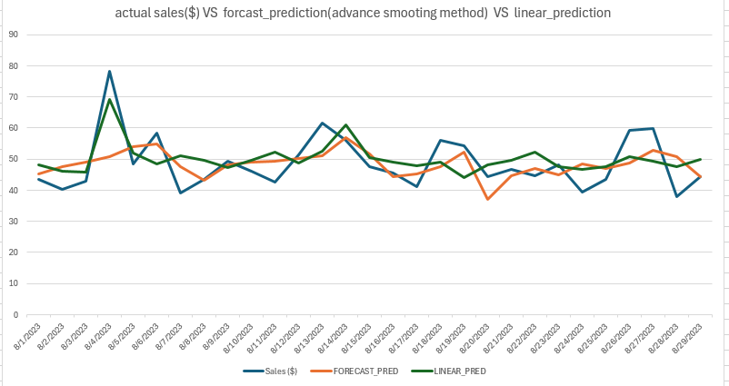

**Chart2** : **Actual vs. Predicted Sales (Linear Regression)**

* This line chart shows how well the **linear regression model** captures the trend in actual sales.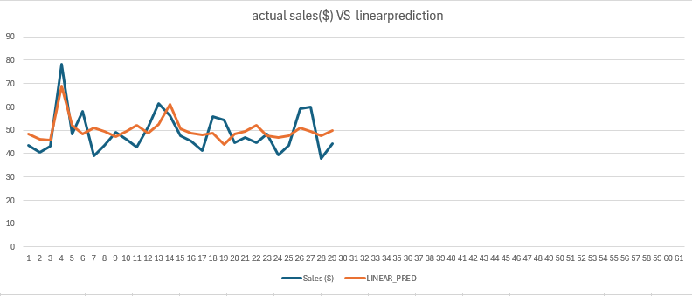

**Chart 3**: **Actual vs. Predicted Sales (ETS Model)**

* This line chart compares the actual sales with the predicted sales using **Exponential Smoothing**.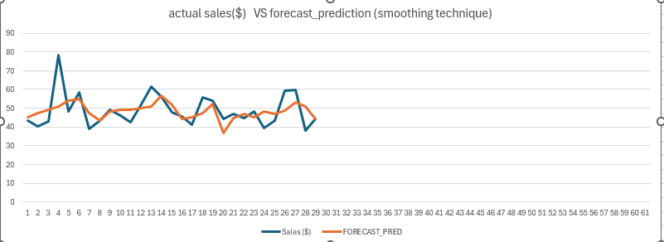

The **ETS model** visually aligns better with the actual sales, indicating that it captures seasonality and trends more effectively.

**5. Insights from Smoothing Techniques**

**Exponential Smoothing techniques Insights**

Smoothing techniques such as moving averages and LOESS (Locally Estimated Scatterplot Smoothing) help to identify trends and patterns in data that may not be immediately apparent due to noise:

* **Moving Averages**: This technique smooths out short-term fluctuations and highlights longer-term trends by averaging data points over specified intervals.
* **LOESS Smoothing**: This method provides a flexible approach to fitting a smooth curve to data by combining multiple regression models in a k-nearest-neighbor-based manner.
* **ETS** is particularly effective in cases where the data exhibits **seasonal** patterns. The ability to adjust for seasonality (e.g., monthly fluctuations in sales) allows this model to make more accurate predictions, especially over longer periods.
* **Linear Regression** assumes a linear relationship between temperature, special events, and sales. While it can explain short-term sales variations, it may not capture more complex patterns like **seasonal trends** or **non-linear effects**.

**When to Use Each Model**

* **Linear Regression** is ideal for identifying the effects of **specific factors** (e.g., temperature, special events) on sales.
* **Exponential Smoothing (ETS)** is more suited for forecasting **long-term trends** in the presence of **seasonality**.

**6. Conclusion**

The analysis of regression coefficients reveals significant insights into variable relationships, while model performance comparisons highlight effective modeling strategies. Smoothing techniques further enhance understanding by revealing trends obscured by noise in data. Together, these elements contribute to robust statistical analysis and informed decision-making in various fields.

Based on the analysis, the **Exponential Smoothing (ETS)** model outperforms the **Linear Regression** model in terms of accuracy (lower MAE) and better alignment with the actual sales data. For future sales forecasting, especially with seasonal trends, the ETS model provides a more reliable approach.